Connecting what enterprise AI consumed with what it ultimately did.
Traditional application logs explain deterministic workflows. Enterprise AI systems are harder to reconstruct: prompts are assembled dynamically, retrieved evidence changes, model outputs vary, and autonomous agents can initiate irreversible actions. An investigation must therefore answer more than “What API was called?” It must trace the action through its runtime context to the data that entered the AI supply chain.
This requires two connected controls: an upstream cryptographic provenance ledger and a downstream AI black-box recorder.

Provenance Before Intelligence
Provenance begins before a document becomes a RAG embedding or fine-tuning example. At ingestion, the enterprise preserves the original data, produces a deterministic normalized representation, and classifies it for ownership, sensitivity, geography, licensing, permitted purpose, and retention.
The pipeline creates three linked identifiers: a source hash for the original asset, a content hash for each processed chunk, and a derivation ID linking that chunk to its source, transformation code, configuration, and position.
A manifest containing these identifiers and governance metadata is signed using an HSM- or KMS-protected service identity. It is then appended to a Merkle-based transparency log. Signed tree roots and cryptographic inclusion proofs make deleted, substituted, or rewritten records detectable—the same principle used by certificate-transparency systems such as RFC 9162.
Raw documents should not be written directly to the ledger. They belong in an encrypted write-once-read-many evidence vault, while the ledger retains hashes, signatures, policy decisions, and protected evidence references. For RAG, each vector ID maps to its content hash, embedding-model version, index snapshot, and ledger receipt. For fine-tuning, a signed dataset manifest links the resulting model to its approved data and pipeline versions. These records can follow the W3C Entity–Activity–Agent model or OpenLineage dataset/job/run conventions.
Hashing alone is not immutability. Enterprise-grade evidence requires hashing, signatures, retention enforcement, independent monitoring, access control, and separation of duties.

End-to-End Architecture:
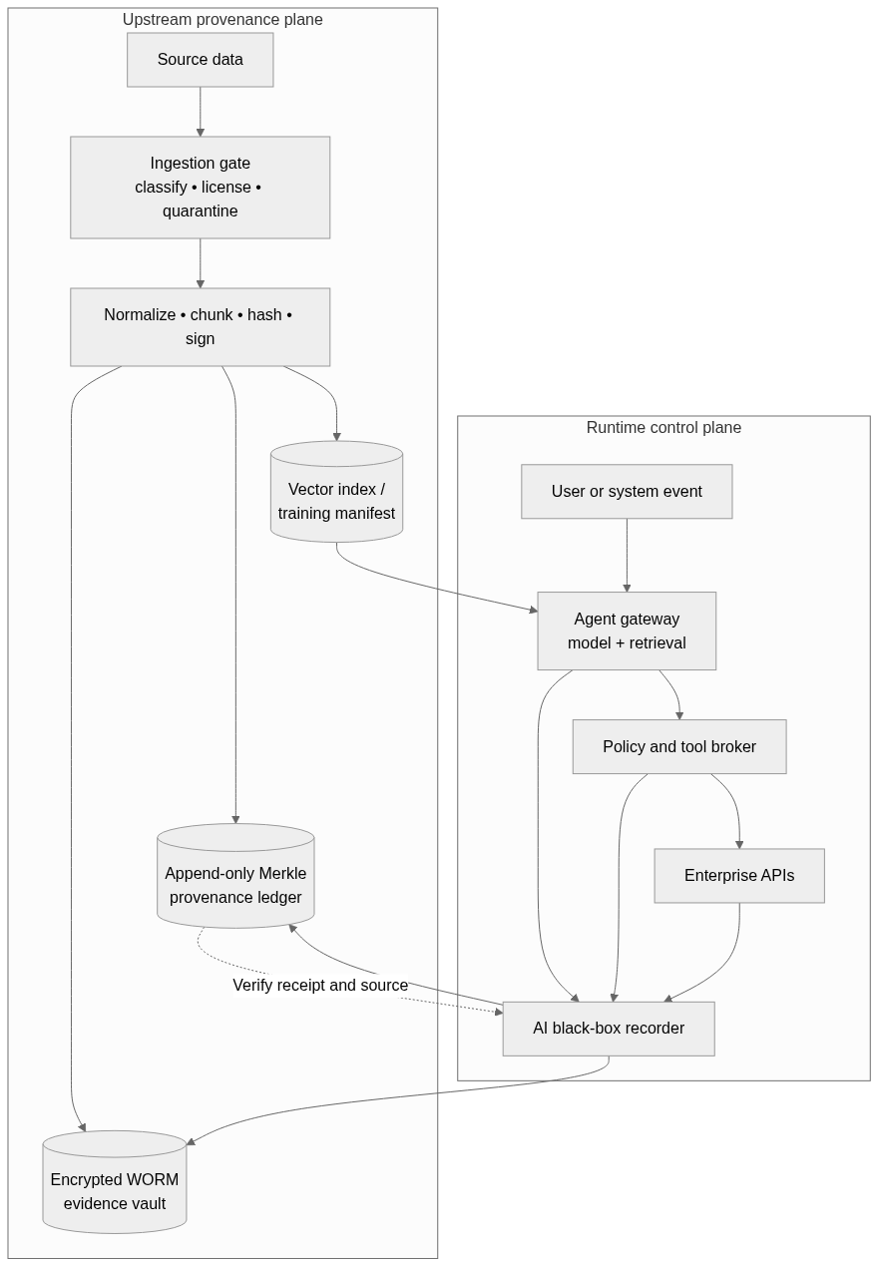

Evidence Before Execution
The black-box recorder operates at an unavoidable execution chokepoint. Agents receive no direct external credentials; database updates, emails, payments, infrastructure changes, and API calls must pass through a policy-enforcing tool broker.
For every transaction, the recorder captures the authenticated principal, model and agent versions, encrypted prompt envelope, retrieved vector IDs and rankings, provenance receipts, policy verdict, human approval, proposed tool payload, destination, external request ID, response status, and result hash.
A two-phase protocol records an INTENT event before execution and links it to a RESULT event afterward. High-risk actions fail closed if the recorder cannot durably commit the intent. Read-only interactions may use signed asynchronous buffering to reduce latency.
INGEST(data):
receipt = LEDGER.append(SIGN(hash, rights, retention))
INDEX.link(vector_or_model_id, receipt)

ACT(tool_call):
intent = SIGN(trace, model, context_receipts,
policy_verdict, tool_call)
REQUIRE RECORDER.commit(intent) if HIGH_RISK
result = BROKER.execute(tool_call)
RECORDER.append(HASH(result), previous=HASH(intent))

The recorder should not treat hidden chain-of-thought as forensic truth. Raw reasoning is often unavailable, and generated explanations may not faithfully represent why a model produced an answer. Research on chain-of-thought faithfulness supports capturing observable evidence instead: instructions, retrieved context, model configuration, policy decisions, tool requests, and resulting side effects.

Closing the Forensic Loop
If an agent sends customer data to an unauthorized endpoint, investigators begin with the external request ID. Its runtime trace reveals the prompt, policy decision, and retrieved vector IDs. Those IDs resolve through the cryptographic ledger to the originating document, transformation, licensing status, and ingestion approval.
The enterprise can then quarantine the source, invalidate derived vectors or model versions, and identify every transaction exposed to it. The evidence proves what information was supplied and what action followed—not that one fragment mathematically caused the neural decision. Exact attribution to base-model weights remains an open research problem.
Aligned with the NIST Generative AI Profile and the EU AI Act’s high-risk record-keeping expectations, this architecture turns lineage into an active risk control. Its purpose is not to read the model’s mind, but to create a verifiable chain of custody across data, context, policy, and execution.

